Fundamental Biomedical Image Processing
Assignment 2
Post Date: Nov. 9, 2020; Due Date: Dec. 7, 2020
NOTE:
- Your assignments / project can be in Matlab, Python, C++.
- You can get extra bonus without using libraries.
- Deadline. The solutions to the assignments / project should be submitted by 12 pm on the date they are due. The late assignments will not be accepted.

Theoretical questions
- Give a single intensity transformation function for spreading the intensities of an image so the lowest intensity is 0 and the highest is L-1.
- Show that subtracting the Laplacian from an image is proportional to unsharp masking. Use the definition for the Laplacian given in Eq.
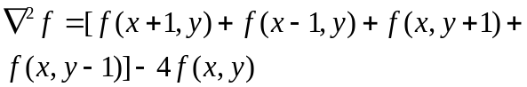

Programming exercises (Send the source code)
- Histogram Equalization
(a) Write a computer program for computing the histogram of an image.
(b) Implement the histogram equalization technique on Fig. 1-1 to 1-4.
- Averaging Filter
Write a computer program of smoothing with square averaging filter masks of size m = 3, 5, 9, 15, and 35, respectively. (Fig. 2-1).
- Roberts Cross Gradient Operators
Write a computer program performing the Roberts cross gradient operator on Fig. 3-1.
- Combining Spatial Enhancement Methods
Write a program to perform a combination of spatial enhancements.
(a) Fig. 4-1
(b) Laplacian of (a)
(c) Adding (a) and (b)
(d) Sobel gradient of (a)
(e) Smoothed with a 5*5 averaging filter of (d)
(f) Product of (c) and (e)
(g) Sum of (a) and (f)
(h) Applying a power-law transformation to (g)

